Using ipconfig, ping, and arp

Time Required: 15 minutes

Objective: Use ipconfig, ping, and arp to view and test network addresses and connectivity.

Required Tools and Equipment: Log into your home computeig command displays the IP address configuration of network interfaces. The ping command sends a message to a computer to verify the capability to communicate with it, and arp displays the MAC (physical) addresses your computer has discovered.

Start your computer, if necessary.

Right-click **Start (Windows ICON on lower left)**  and type **Command Prompt** to open a command prompt window. At the command prompt, type **ipconfig** and press **Enter**.

The ipconfig command output should look similar to this:

**Insert your output here:**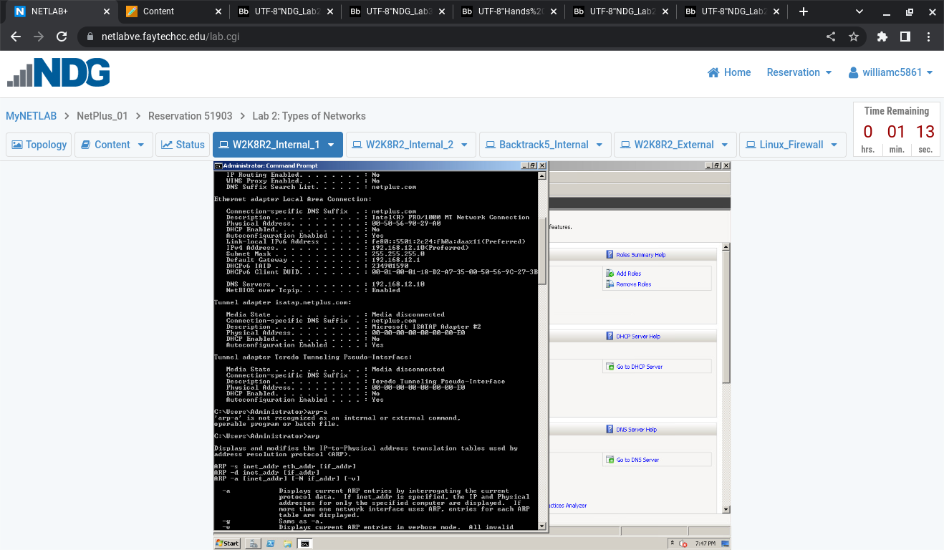

**3**

To see more details about your network configuration, type **ipconfig /all** and press **Enter**. You can scroll up the command prompt window to see all the output. Under the heading “Ethernet adapter Ethernet0,” find the row labeled Physical Address . The number you see in this row is the MAC address, a 12-digit

hexadecimal value. Also, find the IP address in the IPv4 Address row. Write down these two addresses:

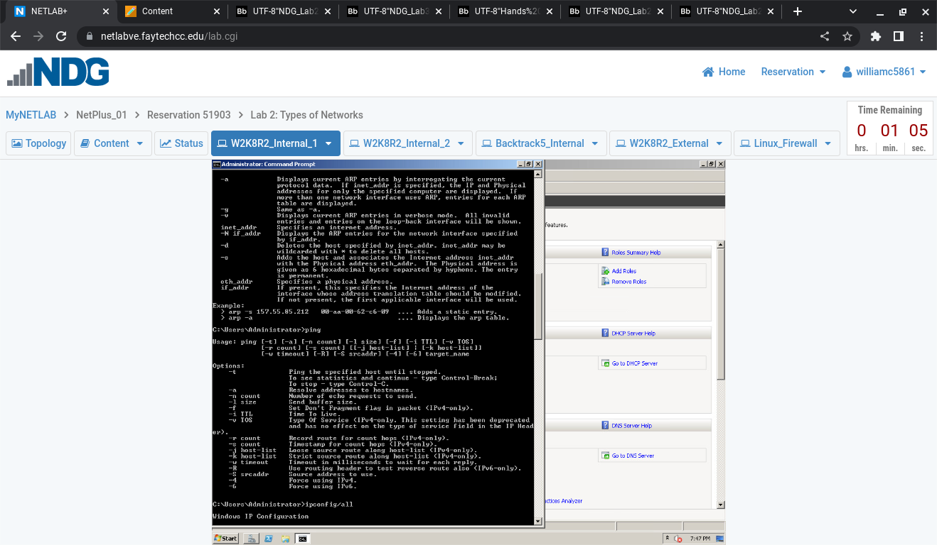

**Insert your output here**:physical address 00-50-56-90-29-A0

IPV4 address 192.168.12.10

4; The arp -a command displays MAC addresses

Type the command arp-a and insert your information here:

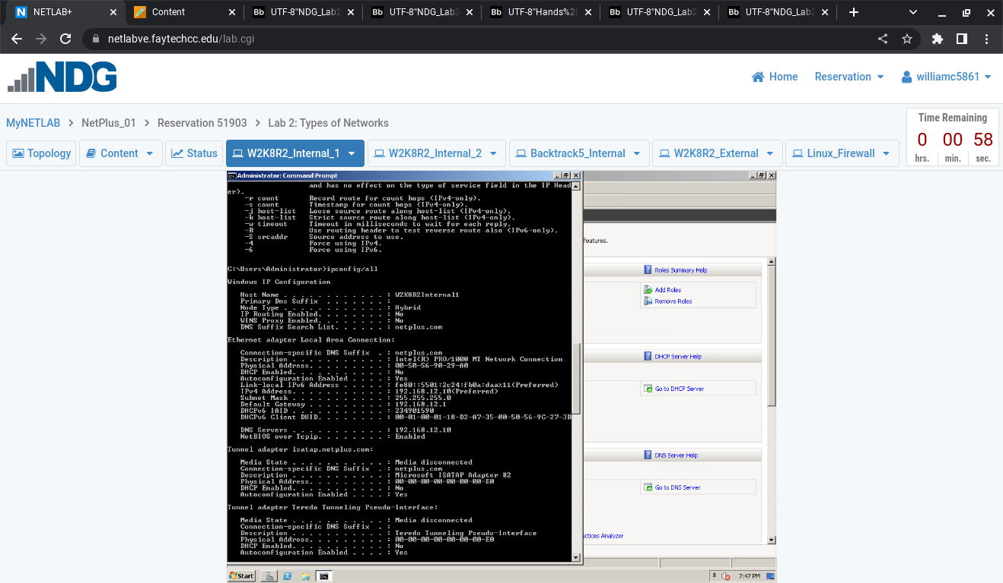

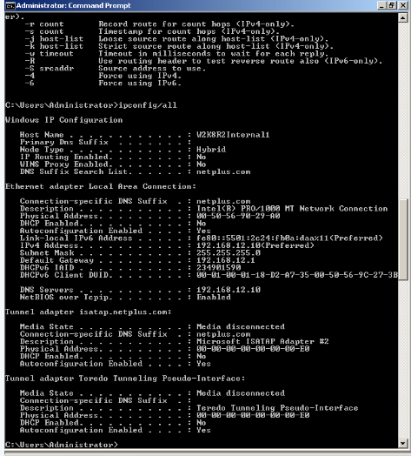

Use the **ping** command to communicate with other computers and devices on your network, and use **ipconfig /all** to find the addresses of your default gateway (a router in your network) and your DNS servers. Write the MAC

addresses of your default gateway and DNS servers (from above) : **Insert it here;**

Default gateway: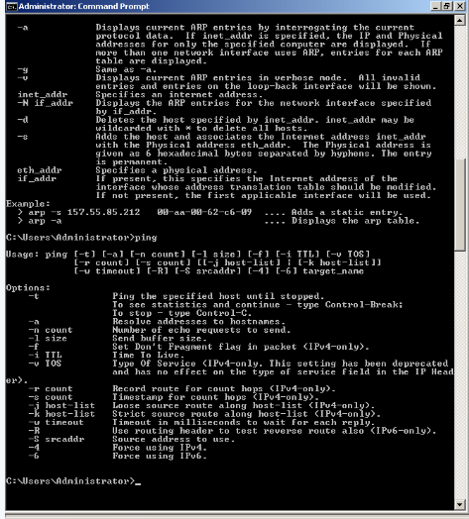

DNS servers:

Close all open windows, but leave your computer running for the next project.